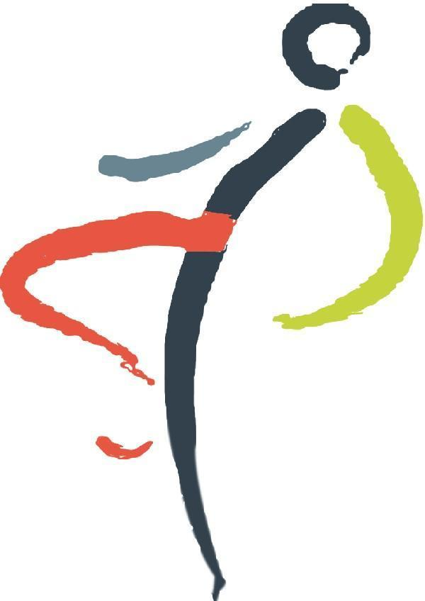
EAST AFRICA PHYSIOTHERAPY
Sports Injury Clinic
Exercise & Sports Medicine Center

Phone: +254 (0) 729 006 837, +254 (0) 792 109 613
Po Box 3603 Nairobi Crescent Medical Aid Building, Next to Pangani Heights, Kiarie Road, Pangani, Nairobi
e-mail: eastafricaphysiotherapy@gmail.com

Official Service Fee Charge Letter

July 27, 2025
United States International University
PO BOX 14634-00800
Nairobi
Through: Millicent Wanderi
Dear sir/madam
I hope this letter finds you well. This letter serves as an official communication regarding the official service charge fee for our Sports Physiotherapy Services at the university. The standard service charge fee of Kshs. 2000.00 is charged per a physiotherapy session. These sessions are thereafter billed together in an official invoice at the end of every month as stipulated in our Contract( SLA) for onward payment processing.
Please note that an addendum on the same can be initiated in the future to reflect the same in the official SLA Contract. Please allow the payments for services to be made so as not to interfere with the ongoing students service provision and inconveniencing our day to day running of the company.
Should you have any queries don't hesitate to get in touch (lamech2030@gmail.com) cell 0729006837 directly.
We value your institution business and are always here to provide our services to your students. Thank you for your prompt attention to this matter.

Sincerely,

Lamech Francis - Director
East Africa Physiotherapy Center

Official Banking Details

BUSINESS NAME | East Africa Physiotherapy Center Ltd
REGISTRATION NUMBER | CPR/2014/161117
SPECIALITY | Physiotherapy
PRACTICING LICENCE NUMBER | PCK0189A
KMPDC LICENCE NUMBER | N/A
ACCOUNT PAYEE NAME | East Africa Physiotherapy Center Ltd
BANK NAME | Premier Bank
BANK BRANCH NAME | Kimathi st
ACCOUNT NUMBER | 0014045801
KRA PIN | P051620111H
BUSINESS POSTAL ADDRESS | 3603-0200
BUSINESS PHYSICAL LOCATION | Crescent Medical Aid, Pangani
MOBILE/TELEPHONE NUMBER | +254 729 006 837
EMAIL ADDRESS | eastafricaphysiotherapy@gmail.com
NAME-ACCOUNT SIGNATORY | Lamech Francis
DESIGNATION | Director
SIGNATURE

COMPANY STAMP/SEAL | BANK STAMP /SEAL
East Africa Physiotherapy & Sports Injury Clinic
Always Keeping you of the sidelines

